**Power BI Installation Assignment**

**Assignment – 1**

• Install Power BI Desktop and share the final screenshot of the report view page which appears when power desktop starts.

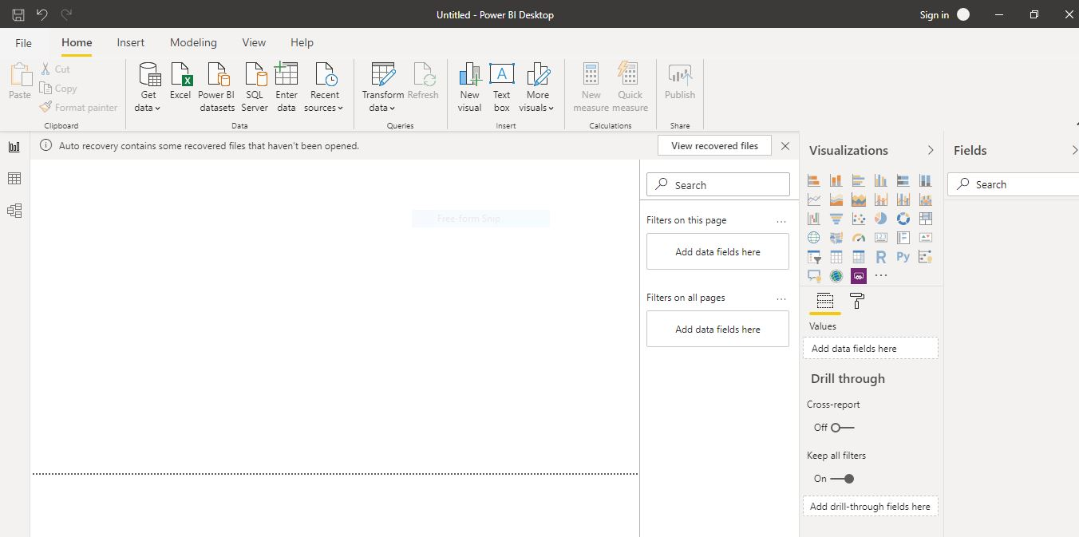

• Prepare a document and with the following screenshot

− Report View



− Data View

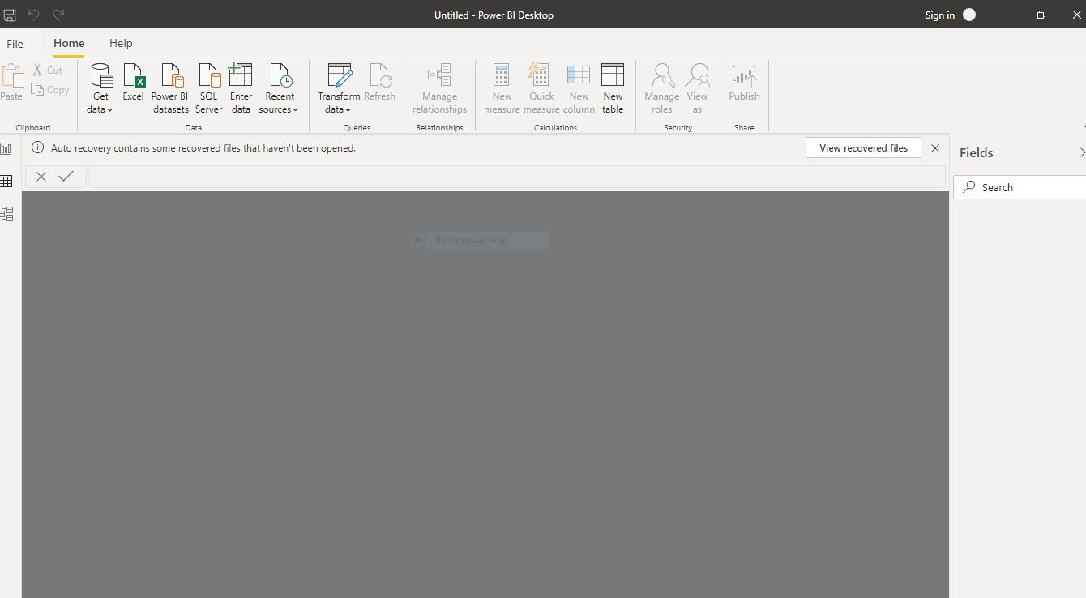

− Model View

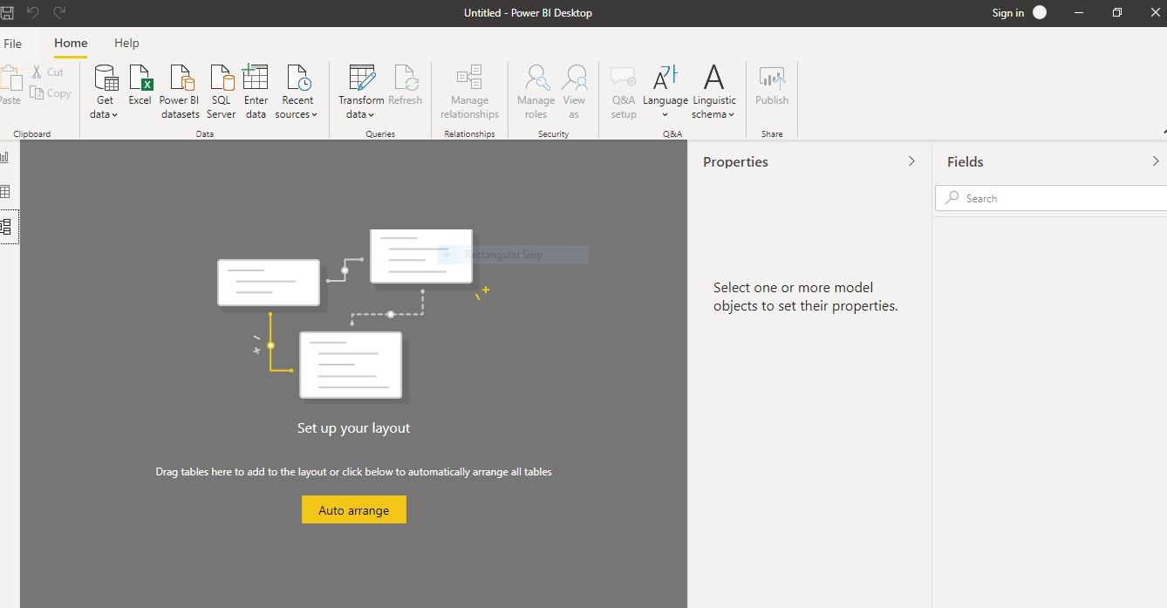

* Power Query Editor

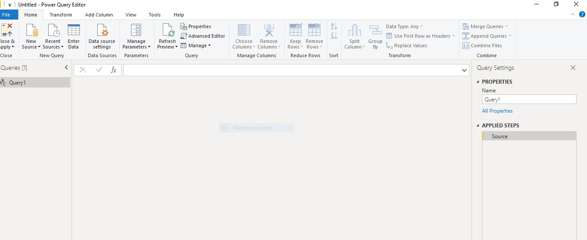

− Advance Editor

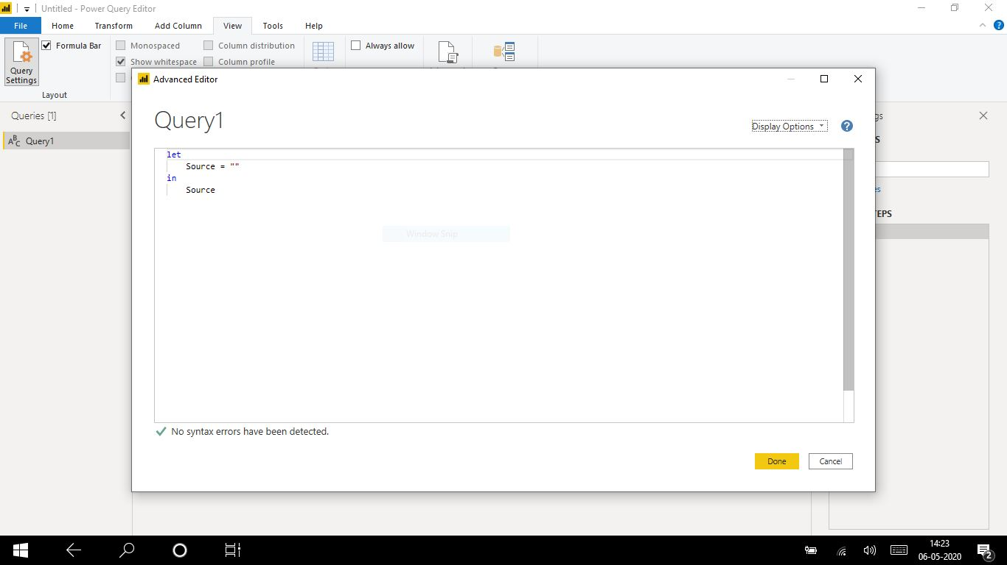

• Prepare a document with details of the following along with their price

− Power BI Desktop

− Power BI Pro

− Power BI Premium

Power BI comes in three levels – Desktop, Pro, and Premium. The Desktop level is free for individual users, while the Pro plan costs $9.99 per user per month. The Premium plan starts at $4,995 a month per dedicated cloud compute and storage resource.

Power BI Desktop – Power BI Desktop integrates proven Microsoft query engine, data modeling, and visualization technologies. Data analysts and others can create collections of queries, data connections, models, and reports, and easily share them with others. Through the combination of Power BI Desktop and the Power BI service, new insights from the world of data are easier to model, build, share, and extend.

Power BI Desktop centralizes, simplifies, and streamlines what can otherwise be a scattered, disconnected, and arduous process of designing and creating business intelligence repositories and reports.

It does not allow peer to peer sharing and creating app workspaces though.

Power BI Pro – Power BI Pro allows sharing the data, reports and dashboards with other users who also have Power BI Pro license. We can also create app workspaces.

Power BI Premium – Power BI Premium is an on-premise deployment and distribution of Power BI reports using the Power BI Report Server. This allows you to maintain reports on-premise and move to the cloud when your organization is ready.

Power BI Premium is designed to address the challenges of large enterprise deployments and workloads. It enables your organization to use your own dedicated capacity and hardware rather than relying on Microsoft’s shared capacity. You’ll need to provide that capacity and ensure you have enough for your reporting and analysis purposes. This allows for much larger scale and better performance if you size it properly. Microsoft offers three sizes for Premium capacity and each come with a different number of v-cores and memory size.